Filter Transformation

-- for source qualifier

create table account(

accid number(4) primary key,

name varchar2(30) not null,

balance number(9,2));

insert into account values(101, 'savings', 3333);

insert into account values(102, 'current', 4444);

insert into account values(103, 'savings', 3232);

insert into account values(104, 'demat', 2222);

**Target**

create table t_account_filter(

name varchar2(30) not null,

balance number(9,2));

In Designer

GOTO – Source qualifier and get the source table and got target designer and get the target table

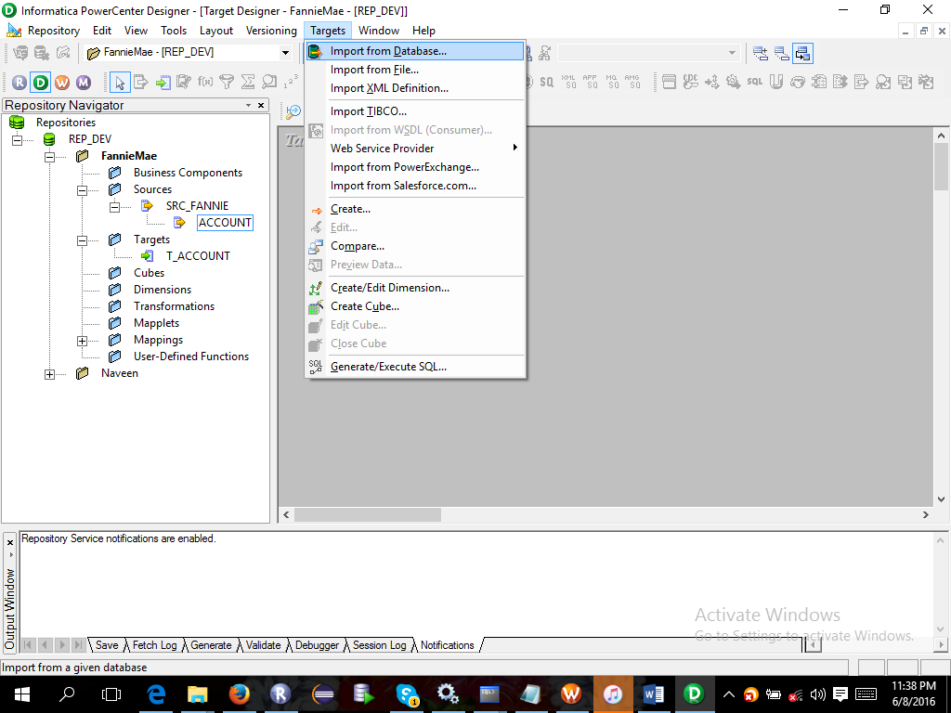

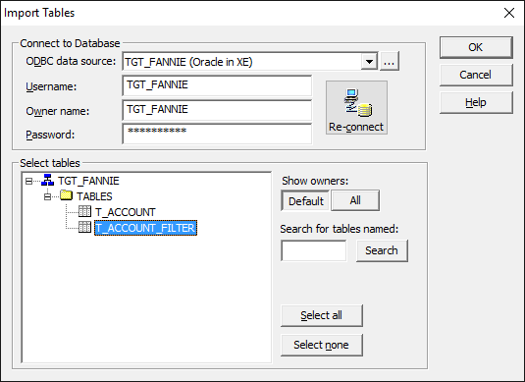

Take source and target tables to mapping designer as shown below

PU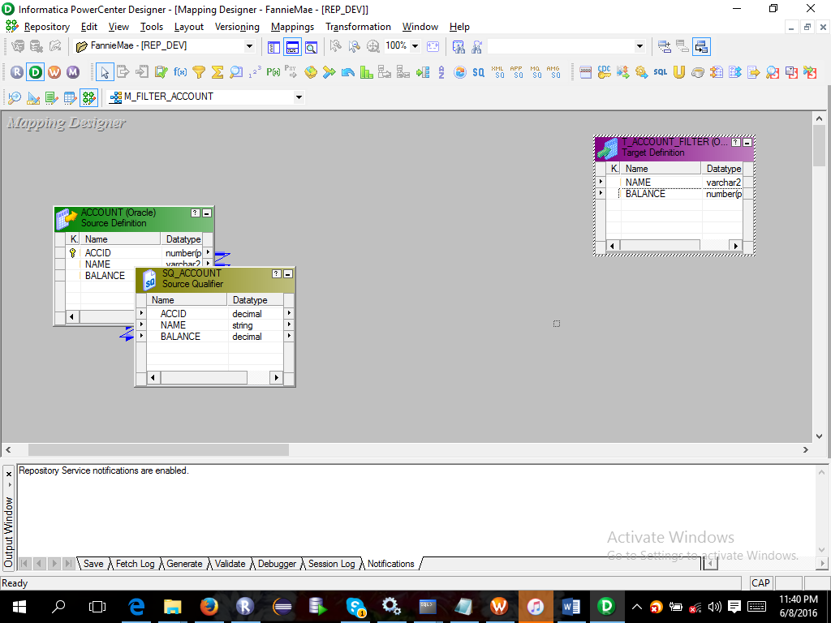

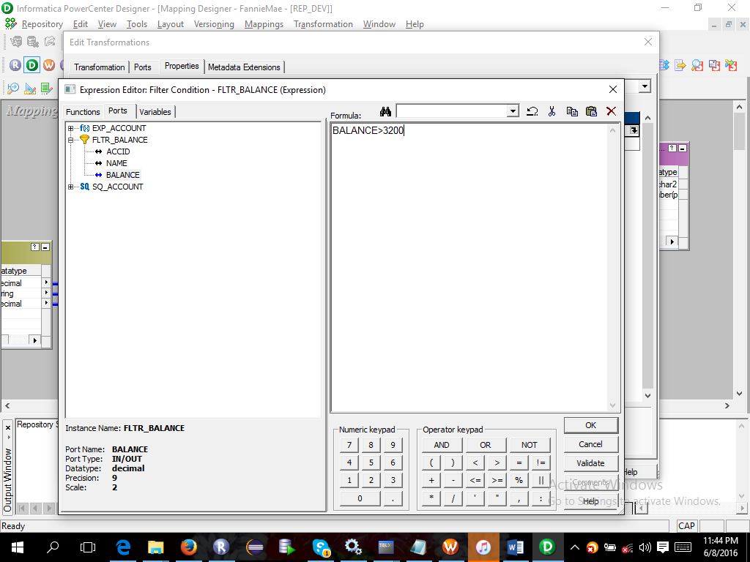

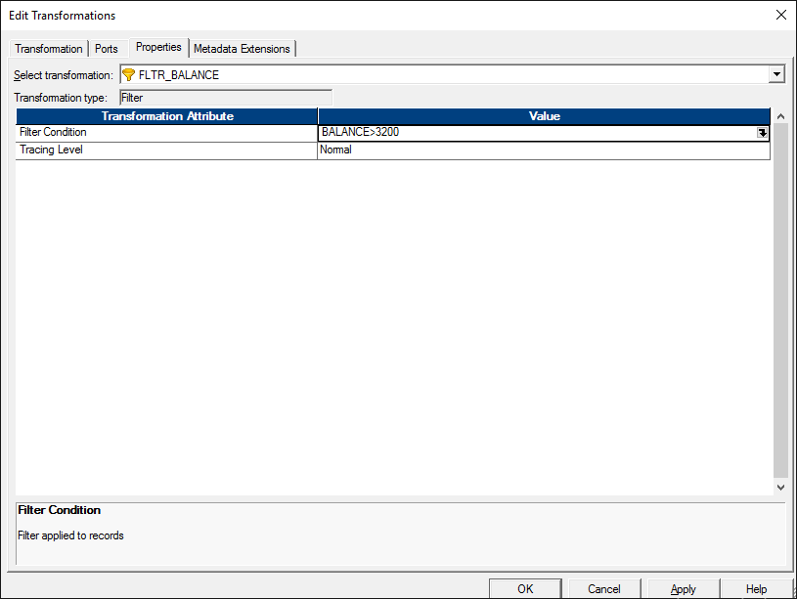

GOTO workflow manager and

